**Assignment -1**

**Python Programming**

|  |  |
| --- | --- |
| Assignment Date | 19 September 2022 |
| Student Name | Shibi M |
| Student Roll Number | CITC1907044 |
| Maximum Marks | 2 Marks |

## Question-1: Split this string

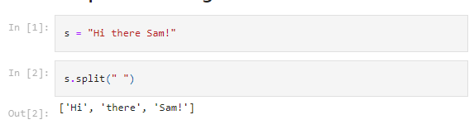

## Question-2: Use .format() to print the following string.

## 

## Question-3: In this nest dictionary grab the word "hello"

## 

## Question-4.1:  Create an array of 10 zeros?

## Question-4.2: Create an array of 10 fives?

## 

## Question-5: Create an array of all the even integers from 20 to 35

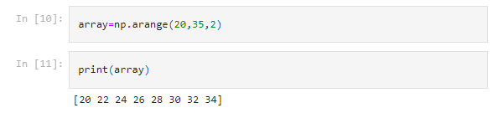

## Question-6: Create a 3x3 matrix with values ranging from 0 to 8

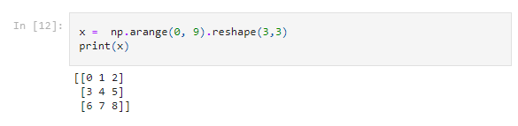

## Question-7: Concatenate a and b

## a = np.array([1, 2, 3]), b = np.array([4, 5, 6])

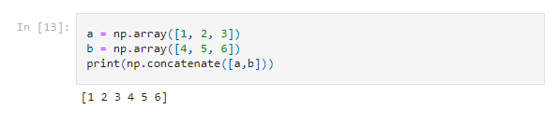

# Pandas

## Question-8: Create a dataframe with 3 rows and 2 columns

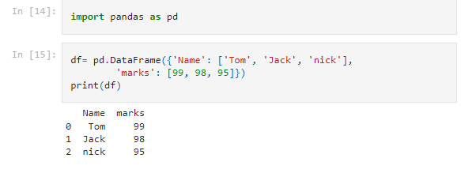

## Question-9: Generate the series of dates from 1st Jan, 2023 to 10th Feb, 2023

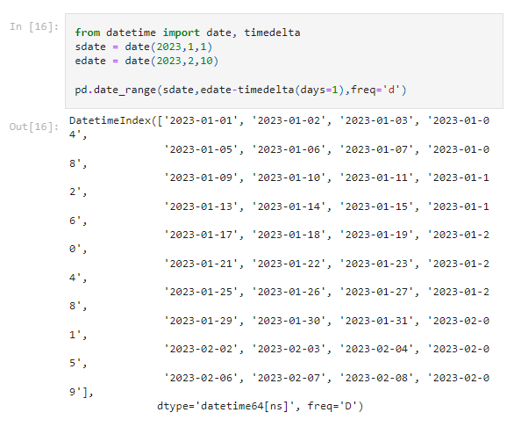

## Question-10: Create 2D list to DataFrame

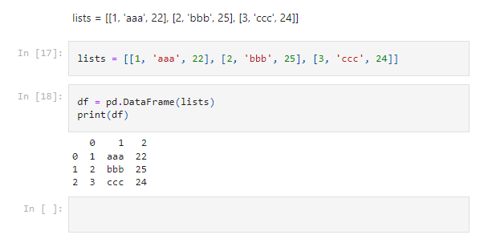

**9ed6fea388cd47310613a113802c9e3d**